Lovebytes
A Computer Dating Service for Young Adults
Business Plan
Ventana High School
14100 Ridge Road
Ventana, CA 93888
805-555-1212
Lovebytes@Gmail.com

Jerry Belch

October 30, 20XX
Table of Contents
- Introduction
- Purpose of Plan page 3
- Executive Summary page 3
- Mission Statement page 3
- Business Objective page 4
- Company Description page 4
- Description of Staffing page 5

II .Operating Procedures
- Operating Procedures page 8
- Process page 9
- Planning page 9
- Organizing page 9
- Directing page 9
- Controlling page 9

III. Market Analysis
- Market Analysis page 12
- Strengths and Threats page 13
- Marketing Plan page 14
- Marketing Mix page 14
- Product/Service page 16
- Placement page 17
- Price page 17
- Promotion page 18
- Target Market page 18
- Market Segment page 18
- Competitive Analysis page 18
- Break Even Analysis page 19
IV. Financial Data
- Balance Sheet page 18
- Projected income page 22
- Cash Flow page 30
- Financial Write Up page 33
V. Appendix
A. Loan Application page 34
B. Start up Budget page 37
C. Amortization Table page 38

Purpose for the Business Plan
The reason for writing the business proposal is to obtain a loan to cover the first three months of operating expenses. Another reason is to obtain the necessary equipment, furniture and fixtures, obtain a domain name and secure a server large enough to handle our clients' needs. By writing this business plan it gives direction to our company, establishes goals and sets income, expense and profit projections
Executive Summary
The company Lovebytes is an on-line, computer dating service for young, single adults, and aged 16 to 22. The survey is taken on-line from our company web site. Results are compiled and matches are revealed to our customers in the areas of physical appearance, interests, lifestyles, backgrounds, personal energy, outlook, predictability and decision making. In addition, profiles are generated for: Date Potential, Personality, Job/Career Aspirations, Character and Family Values. The focus of our business is not on Mister or Miss Right, but for Mister or Miss Right Now. We do not believe in the myth that young adults have no problem meeting people and getting dates. One of our objectives is to prove that it is a cool thing to use computer dating and not as a last resort. The market we will target, numbers 24% of the total population in the United States of 102 million. This segment of our population has declined somewhat in recent years, but we believe that there is an excellent opportunity to interest them in our service. We plan to conduct marketing research to determine which traits young people are looking for in a date and design our questionnaire or survey accordingly to make excellent matches. Our company's management believes that we must be successful in finding matches for our current clients for continued growth and profitability. We believe that our target market clients, 16 to 22 year olds, are busy with school, sports, work and other activities and can really benefit from using our service. Our competitors, Match.com, E-Harmony, Chemistry.com and Perfect Match appeal to a slightly older market segment. Their focus is on long-term, lasting relationships. We are not committed to matching up people for long-term commitments, but provide a way for young adults to spend time with each other in a short-term relationship. After using the software to find matches and profiles, pictures and records that are a good match will be emailed to clients. We will use Internet-based advertising to promote our service, including social media. Our management team is well qualified to provide the maximum experience for our clients at a competitive price. Our balance sheet shows that we have a good amount of operating capital. We will apply for a loan using the Business Contract through the Virtual Enterprise center.
Our income projections show a slow, but steady growth and our cash flow analysis demonstrates that we will have adequate cash on hand to pay our obligations. Our SWOT Analysis shows no unnecessary risk involved in our venture. Our strengths outnumber or weaknesses. We will offer a yearly package (12 months) that costs $395.40. It can be paid in monthly installments of $32.95. We will bill our clients if they choose this option.

Mission Statement
It is our mission to provide a cost effective, superior computer dating experience for young, single adults who are looking for short-term relationships. We will use an on-line survey questionnaire to collect the data and then run it through our specially-designed, match making computer software to find matches of compatibility in the areas of activities, interests, sports, hobbies, music, movies and other forms of entertainment.

Business Objectives
We plan to break-even the first month in operation. Our sales staff is committed to increasing sales each month. We will begin our operations in the California Virtual Enterprise network first, and then next year expands into other Virtual Networks including international networks. After taking a 25% market share we want to expand the product line to include a deluxe matching package that will include the following additional features: Instant messaging, ability to use the program on mobile devices, translate the software and questionnaire into other languages.
Develop Internet advertising targeted to high school students that can be emailed to each Virtual Enterprise company.
Company Description
The type of business that we are planning to operate is classified as 812990 - All other personal services segment according to the North America Industry Classification Systems. NAICS has classified over 20,000 industry segments. Our company's main product/service is composed of an on-line computer dating service for high school aged students. We are in the highly competitive computer match making market. We are an S corporation and the stock is held within our company by our employees. Our organization provides a matchmaking service for high school and college aged students for a reasonable fee. We are located in Ventana, California at 14100 Ridge Road. Our phone number is (805) 555-1212. Our web page is http://Lovebytes.com. Our E-mail address Lovebytes@gmail.com Our company originated in September 20xx.

Description of Staffing (Key Personnel)

Virtual Enterprise Job Descriptions Examples

Chief Executive Officer: $90,000 per year
Oversees and directs the company: Responsible for managing and leading the business planning process; Implements our company goals and department policies; Coordinates department tasks; Significantly oversees and contributes to the writing of our Business Plan and Annual Reports; Represents our company at all business functions and Oversees the legality of all actions in the company.

Chief Financial Officer: $80,000 per year
Manages the Accounting Department; Delegates responsibilities to members of the Accounting Department; Formulates and directs the company’s overall financial plans and policies; Creates, interprets, and reports on weekly, monthly, and yearly financial reports; Determines company’s operating expenses; Reconciles Bank Accounts; Manages employees in Accounts Receivable, Accounts Payable, Payroll and Bank Branch Manager.

Vice President of Sales: $65,000 per year
Responsible of assisting in the management, creation, and implementation of the marketing strategy for the company through a business, technical and sales perspective; Researches, creates and presents the Phantom Contract; Initiates and manages discussions and sales with other companies; Negotiates agreements concerning large company sales contracts’ Oversees the company’s Sales department; Analyzes sales trends and recommends aggressive sales strategies in order to maximize company profit.

Vice President of Marketing: $65,000 per year
Develops the company’s marketing objectives, (including Target market and Marketing mix, etc.); Effectively implements the company’s strategic marketing plan; Researches and determines the company product and service line’ Conducts weekly department meetings to distribute tasks and adjust the company’s product line to maintain our competitive edge; Recognizes and reacts to industry trends to maximize profits; Creates and maintains and submits to our IT department our company’s product line.

Vice President of Advertising: $65,000 per year
Directs the development and implementation of the company’s advertising strategy through the promotion of the company’s products and services via creative, attractive, and effective advertising campaign; Assists in the design of the Business Plans and Annual Report, (both written and electronic); Oversees the creation and preparation of the company sales catalogue, bi-weekly advertisements; special advertisements, trade fair ads and all sales materials; Oversees the creation of each employee’s business card and name badge; oversees the creation of posters for the office and trade fair booths.

Vice President of Human Resources: $65,000 per year
Manages the Human Resources Department: Creates, manages, and controls all personnel files; Addresses and participates in all aspects concerning personnel hiring, reprimands, and termination’; Maintains employee attendance and leave records; Establishes and monitors individual employee improvement plans; Determines payroll and withholdings; Manages the employee health insurance program; Creates and updates the Employee Manual; Monitors employee compliance of company policy; Oversees and assists in maintaining the company newsletter and company photo album.

Vice President of Information Technology (CTO): $65,000 per year
Oversees the creation and maintenance of the company’s web site; Supervises and gives direction to the web development team; Coordinates with Marketing Department to include all product; weekly updates to include special offers; Posts HR interest stories on web site; Creates links for our Business Partners; configures the online shopping cart; Assists staff with computer related issues; Trouble-shoots technical issues.

Administrative Assistant: $65,000 per year

Creates company reports; Oversees administrative procedures; Compiles and submits Quarterly Task reports to the Virtual Enterprise Coordinator; Schedules meetings and prepares agendas; Edits company reports; Manages the company’s email; Assists in the management of the company’s web orders; Maintains the company’s Work Samples binder; maintains company’s communication with Business Partners and Virtual Enterprise Central.

Event Planner: $45,000 per year
Coordinates all special company events, such as Trade Fairs, Grand Openings, Open Houses, etc; Oversees the design of our company booth and coordinating all needs for each trade fair. Coordinates all events, invitations, RSVP’s and coordinating refreshments for each special event.

Sales Associate: $45,000 per year
Sells company products and services via email to potential customers; Researches and reports on new and inventive products/ services that could prove profitable for the company; Assists in sales training of additional staff when necessary for Trade Fairs, Grand Opening and other events.

Marketing Associate: $45,000 per year
Researches and assists in the determination of the company product and service line; Assists in maintaining the company’s product/service line on our web site; Conducts weekly research to locate new and innovative products/services; Makes recommendations to management to add new offering to the companies line.

Advertising Associate: $45,000 per year
Assists in the implementation of the company’s advertising strategy through the promotion of the company products and services via creative, attractive, and effective ad campaigns; Assists in the creation and preparation of the company sales catalogue, weekly advertisements, trade fair advertisement ads and all sales materials including order forms.

Accounts Payable/ Payroll/ Accounts Receivable: $65,000 per year
Accounts Payable/Payroll: Processes payment for all company expenses including payroll; Completes the monthly Accounts Payable report; Creates and processes purchase orders to restock inventory; Assists the Branch Banker in the creation of employee personal checks. Creates, manages, and processes payroll through our accounting program; Maintains hard copy files of accounting records.

Accounts Receivable: Process all company invoices through our accounting program; Makes receipt of customer payments; Follows up on outstanding invoices; Creates and reports at the end of each month, the status of accounts receivable; Resolves any incorrect customer payments.

Branch Banker: $65,000 per year
Establishes and manages the company bank accounts through CA US Network Bank; In-services all employees on the use of the US Network Bank and maintenance of their personal checking and savings accounts; Creates and manages the Visitor account through US Network Bank; Electronically transfers company expenses; Processes all company and employee checks to verify clearance through US Network Bank; Communicates with the Accounting Department concerning US Network Bank processing discrepancies; Completes a weekly report, which summarizes company and employee US Network Bank discrepancies.

Human Resources Associate: $45,000 per year
Assists in the creation and maintenance of all personnel files and benefits; Assists in maintaining employee attendance and leave records, creates documents and certificates for recognition of employee performance; Assists in the creation of our Employee Manual; Assists with the creation of the monthly company newsletter.

Web Designers: $45,000 per year
Creates and maintains the company’s web site; Updates web site bi-weekly to include special offers; Posts human resources interest stories to web site; Configures and modifies the online shopping car to reflect current specials; Assists the Advertising Department with ads for the company.

The founder and CEO is Jerry Belch. He is s part-time sales representative and
bookkeeper. He has taken a course in Microsoft Visual Basic and one in web design.
The CFO has a part-time job doing bookkeeping for a local firm and has taken a computer accounting class. Our Vice President of Sales has been employed at a local retail clothing store and taken a course in Marketing. Our Information Technology Vice President has been president of our school's webmaster's club. Our Human Resources person has been an officer in the Associated Student Body organization for two years.

The software we use to run the dating service part of the business was created by our CEO. We have 18 employees: A Chief Financial Officer, A Chief Financial Officer, Payroll Specialist,
Accounts Receivable Clerk, a General Ledger Clerk, An Administrative Assistant, Vice President of Information Technology, a Webmaster, four IT Associates to help process the data,
a sales force consisting of a Vice President of Sales and Marketing, four sales/marketing assistants and a
Vice President of Human Resources.

II. Operating Procedures Management Functions 15 points - 15%
Operating Procedures
The following areas are the core areas of our business plan. They deal with our internal operations of accomplishing our goal of providing the best dating experience through a matchmaking company at an affordable price for young adults.
Selected Areas that need to be addressed
Our company is located in room B7 at our high school; 14100 Ridge Road, Ventana, CA. It is a computer lab which serves us nicely based on the type of business we are operating. We have no physical presence in the community since we do not have a brick and mortar building. We only conduct our business over the Internet. Currently we have only one location, but as we expand, we will acquire a larger facility to house our growing staff. Our office space is quite large approximately 50 feet by 40 feet - 2000 square feet. We have 25 personal computers that are networked with four printers. Again our goal is not trying to find life's soul mate, but a date for now. Since we are Internet based our location is not of great importance as we can process our matches anywhere we have staff to collect and collate the data and make the matches for our customers. We communicate with our clients using email and texting. The results of the matches for our clients will be e-mailed to them.
Process
Since we are a service business, we do not have an inventory or any of the complications that accompany it. We do not need a warehouse to hold our inventory. We do not need a staff to transport and warehouse the inventory. We distribute, our “Product”; or service using email. We email the customer his or her top five matches each month and a picture of each match. The profile includes name, age sex, address, and other physical information contact information so the client can make connections with their matches.
Planning
The goal of our matchmaking business is to find dates for young people while still in school. Our matchmaking is not the forever type, but is designed for our clients to enjoy the fun of going on a computer date with someone with the same interests. The following strategies will be utilized to obtain our goal. We will create an online computer questionnaire designed to capture client interests, likes and dislikes, hobbies, school activities, etc. Our company will use a specially designed program to accurately measure these traits and find others with the same interests. Once the data is tabulated and matches are found, the results of their particular matches will be emailed to each person. The software, questionnaire and process will be test marketed using one school and about 100 participants. The management will hold a meeting after the test marketing is completed to decide if they need to make any changes in our plan. We want to make certain that the information collected is actually representative of how our respondents feel on a particular issue. The Lovebytes program and/or questionnaire can then be revised to make certain that we are measuring the right traits and coming up with meaningful matches.
Organizing
Here is our organizational chart
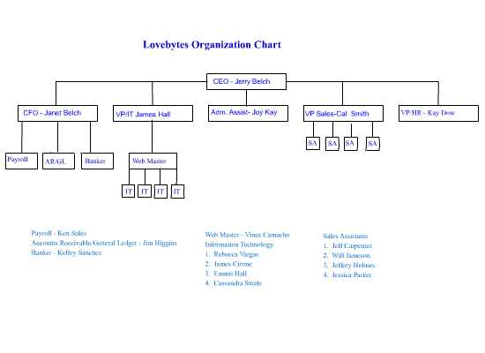

Directing
The CEO completes a department by department list of objectives for the week. Each Friday all of the Vice Presidents meet with the CEO and have a meeting to discuss what should be accomplished
in the next week. From the information contained on the weekly department objective sheet, the vice president for each department lay out the goals for the week for each person in their departments. On Monday morning, each department has a meeting with their staff to go over the goals for the week.
The vice president of each department assigns each person in the department their individual tasks
needed to accomplish the weekly goal.
Controlling
At the end of the week each employee indicates how they did on the completion of their tasks: finished, partially done or not finished and comments explaining their answers. The vice president of the department then rates the performance and attitude of each employee as to unacceptable,
needs improvement, meets expectations, exceeds expectations or superior. Attendance is also recorded on this form indicating attendance and tardiness. This form is then turned over to the CEO who either agrees or disagrees with the vice president's evaluation. This form is filed in a folder for each employee
These folders with the weekly forms are looked at during the employees' evaluation process.
Evaluation forms are filled out by the department manager indicating areas that are excellent,
needs improvement and if a raise in pay is going to be given.

III. Marketing Plan 30 points - 30%
Industry Analysis
Competitive national trends
The matchmaking industry had been fairly stagnant for a number of years, but within the last three years, with the proliferation of on-line dating services, the entire industry has been rejuvenated. More and more people are turning to on-line dating. The on-line movement has helped legitimize the entire industry.
There are 40 million users with 1.9 billion dollars in revenue generated each year. The on-line services moved the paper and pencil model to reach a new audience. The market is composed of a number of types of dating services: Online where questionnaires are completed on-line and a computer program is used to find the matches and create profiles of the respondents. Newspaper-based personals are another form of dating service, where people write a little about themselves and/or who they are looking for and people respond accordingly. Then there are the traditional matchmaking services that do not use a computer but calculate the matches by hand. Some interesting facts about the dating market are that 81% lie about their height, weight and age in their profiles. The average couples who meet, wait 18.5 months to marry. Those who do not meet on-line wait 42 months before getting married. Almost one half of men and women Google their date before meeting them. People with Internet connections were much more likely to be in a relationship, 72% then those without 46%. Heterosexual couples, who met on-line, rose for 0% to 20% from mid 1990's to 2010.
The mobile dating market is expected to be worth 2.3 billion dollars by 2016. Twenty one percent of couples meet on social networking sites. There are 1500 dating sites in the United States. Seventy seven percent of Americans reported going on two or more dates this past year. Revenue from on-line dating grew 3.5% from 2007 to 2012. Out of the 55 million singles in the U.S., 5.5 million use a dating service. Sixty four percent of on-line daters say that common interests are the most important factor in finding a partner. Forty nine percent say that it is physical characteristics. One of the major players in the dating market is E-Harmony. They compare 29 dimensions of compatibility with the goal of creating long-lasting relationships. They have a free version with limited functionality. They have a basic plan and an advanced one. Perfect Match is another major competitor in the dating services market. They use advice columns and articles, conduct single events in the area and send ice-breakers to prospective dates. Their questionnaire examines impulsivity, personal energy, outlook predictability, flexibility and decision making abilities, Chemistry.com matches singles by chemistry or underlying attraction. Match.com is another significant player in the dating services market.
Identify Strengths and Threats
One strength in our business plan as far as the industry analysis is concerned, is that we are an on-line competitor which makes us appear scientific in our match making. Another strength is that our target market is very specific and aimed at high school aged and college aged students. Most other dating services focus on other market segments. There will always be others that want to tap our market as soon as they see how successful we are. Another threat comes from the ever-changing technology. With the proliferation of tablets, smart phones, etc. we will need to develop a programming format that runs on those platforms.
Compare company vision and experience against averages of similar operations.
Our company employees know the market better than anyone when it comes to teen dating and their input in designing the questionnaire will be on target for making matches with Mr. or Miss Right Now. Since we are a virtual company and have inside access to the age group we are targeting, we will have an advantage. We also have lists of all possible customers, whereas our competitors would have to purchase this data. We need to make our clients feel that it is cool to use a computer dating service for lining up dates for special occasions including proms. To accomplish this we will select some of the most popular students at school, offer them a significantly reduced rate for our service.

Marketing Mix 10 points 10%
Components of the Marketing Mix
Our questionnaire is an online questionnaire and it appears below. It is part of our service where collect information about our clients.

Lovebytes Computer Dating Survey
Client Dating Information Section
Last name
First name
High School
Male
Female
Street Address
City State Zip Code
E-Mail Address
Age: 16-17 18-19 20-22
1. My idea of a romantic evening would be a walk on the beach. AS AM DM DS
2. My favorite kind of movie is: Drama Adventure Comedy Science Fiction
3. My idea of a perfect Sunday is watching as many football games as possible. AS AM DM DS
4. My idea of a romantic weekend would be to stay at a cabin at the beach AS AM DM DS
5. You are a _______ person? Morning Afternoon Evening Energetic All the time
6. If you spent a week together, you would: spend: An afternoon apart, a few afternoons apart, be together 24/7, Sneak out when given a chance
7. The idea if surfing or skiing sounds: Exhilarating, A good time, Pretty Exhausting, A death wish
8. I would love a vacation where I would spend a couple of days at the beach: AS AM DM DS
9. Money is no object when you are on a date. AS AM DM DS
10. I love to try new foods. AS AM DM DS
11. When I go to work full-time, I plan to live for the weekend. AS AM DM DS
12. Nowadays it is almost essential that both a husband and wife work outside the home. AS AM DM DS
13. If I won a free trip for a week, I would like to go to :Europe, Hawaii, Caribbean Cruise, and South America
14. The plans for my future include a four-year college degree. For Certain, Pretty Sure, Maybe Not, No Way
15. Making a lot of money is a very important goal in my life. AS AM DM DS
16. A job in which I help others is an important goal for me. AS AM DM DS
17. My favorite kind of food is:. American, Mexican, Italian, Asian/Chineese/Thai
18. A perfect first date would be going to an important school dance. AS AM DM DS
19. My favorite spectator sport is: Football, Baseball, Basketball, and Soccer
20. I am a religious person. AS AM DM DS
21. I am extremely sensitive to any hint of criticism. AS AM DM DS
22. In stores and restaurants, I am quite demanding with the help. AS AM DM DS
23. In a relationship, I believe you should please yourself first then the other person. AS AM DM DS
24. I am a person who needs lots of emotional support. AS AM DM DS
25. I go to extremes to avoid disappointing anyone. AS AM DM DS
26. I have strong opinions and don't mind expressing them. AS AM DM DS

27. I tend to demand perfection from a date or mate. AS AM DM DS
28. If something needs to be said, I will say it no matter whose feelings might be hurt. AS AM DM DS
29. I am very disciplined and seldom give into procrastination. . AS AM DM DS
30. Watch out! I am a dangerous person to cross. . AS AM DM DS
31. It is a disaster to me when I lose someone's friendship. . AS AM DM DS
32. I find it easy to simulate emotions I don't really feel. . AS AM DM DS
33. When I care for someone, I try to anticipate his/her wishes and desires. . AS AM DM DS
34. I think it is important for each person to own a car. . AS AM DM DS
35. My parents and I get along great. AS AM DM DS
36. Being grounded is worse than death. . AS AM DM DS
37. I date at least _________ at a time. one person, two people, three people, four or more people
38. If you eventually marry, how many children would you like? None, One, Two, Three or more
39. Being on time is extremely important. . AS AM DM DS
40. Achieving high social status is an important goal in my life. . AS AM DM DS
41. Being kissed on the first is very important. . AS AM DM DS
42. I could not live without my cell phone. . AS AM DM DS
43. Social media cites like Face book and Twitter are an integral part of my life. . AS AM DM DS
44. I consider myself to be handsome/beautiful. . AS AM DM DS
45. Having the latest styles and fashions of clothing is very important to me. . AS AM DM DS
When the person is finished with the survey, they press the Send button and the completed questionnaire will be sent to our company's e-mail address. When a significant number of surveys are received, the IT Department staff will merge them together to create a file that will be read and interpreted by the Lovebytes software.
Product/Service
The physical Product/Service offered to the consumer is a matchmaking service that finds similarities of character values, date potential, personality, career aspirations and importance of family.
Each respondent to the questionnaire emails a digital .jpg photo - head shot, to our company since the software uses photos of each client.. The computer software's main screen is shown below
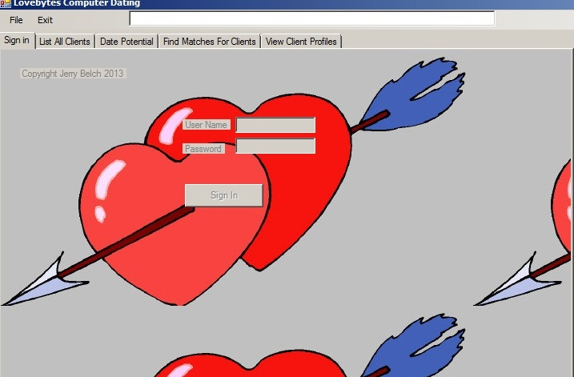
The program elements are accessed by clicking on the appropriate tab. A list of all clients can be viewed, Individual records can be displayed, matches can be found and dating profiles can be generated.
The only tab that is not password protected is the view individual’s records. We want prospective customers to view our data base. To find matches the software will compare these questions and their values to find the best possible date for the client. A slightly modified Likert scale will be used in the software to assign partial points for partial matches. The scale can be used to capture the intensity of the feelings for a given item and responses can be compared for levels of agreement or disagreement. Most of the questions on the questionnaire use this methodology giving respondents the chance to Disagree Strongly, Disagree Moderately, Agree Moderately and Agree Strongly. A profile will then be generated from the software to give our clients profiles on their Date Potential, Personality, Job/Career Interests, Character and Family Values. The results of the matches, the profile and a picture of each match will be emailed to the client.
Placement
The placement used to get our product to the consumer is via the Internet. That is our only channel of distribution. The compiling of data, creating the files, finding the matches and profiles will be handled at our headquarters. No middlemen are needed in our venture thus saving costs.

Price
The price will be competitive. For example, Match.com charges $16.99 per month for six months or $34.95 for one month. Other sites have much the same pricing structure. Lovebytes.com will charge $395.40 ($32.95 * 12) for a one year’s subscription. It entitles the client to 1 match each month or a total of 12. It can be paid monthly at $32.95. We will have trade show discounts and special promotions during December, March and April. Clients who introduce Lovebytes to their friends will receive a 5% discount.

Promotion
Promotion will be accomplished in a couple of ways. The web site will be listed in the Virtual Enterprise shopping mall and meta tag information will be sent to the major search engines. The questionnaire will be attached to the web page. We will create ads that run on the Internet, tied to other Virtual Enterprise sites. Email ads will be created and sent to all Virtual Enterprise companies in US network. Special flyers with trade show deals will be circulated during each of the trade shows. We will run an ad in our school paper and have a spot on the schools TV station featuring popular students in school showing how cool it is to use Lovebytes to get a date for a school activity.
We will attempt to obtain company to company contracts with other VE companies.
Target Market
The target market for most computer dating companies is twofold: the 20 to 35 year old segment and the 36 to 60's segment. Incomes in the younger segment range from $35,000 to $85,000. Fifty-three percent have some college education. Twenty-three percent have graduate degrees. They enjoy spending time with friends. They have a difficult time meeting single, interesting people. They want to avoid bars and nightclubs looking for a date. There is a nine percent growth rate projected for this segment. The income range for the older segment is between $55,000 and $100,000. Sixty-five percent have college degrees. Forty-one percent have been married before. They have trouble finding others their own age to date. They have tried many different methods to find a partner. An eleven percent growth rate is expected for this segment. These companies focus on life-long partners with the end result of marriage.
Target Market Segment
Our target market segment is quite well defined. It consists of high-school aged and college-aged students, single, with a fair amount of discretionary income earned from part-time jobs. The money earned is theirs to keep and does not have to be spent on food, rent, utilities etc. They spend their money on music, entertainment, clothing, etc,. They are very busy with school, sports, extra -curricular activities and work and are in need of our services to find dates for school activities as well as regular dates. They are not interested in life-long partners at this stage in their lives. They are looking for dates with good physical characteristics and people with the similar values and interests. Our company will attempt to debunk the myth that younger people should have no problem meeting people. We want to convince our target market segment, that it is a cool thing to try computer dating, not a last resort. Currently we will focus on students on the US and will later expand our market to include International Virtual Enterprise companies.
Break-Even Analysis
The Break-even Analysis spreadsheet is pictured below is for one month;
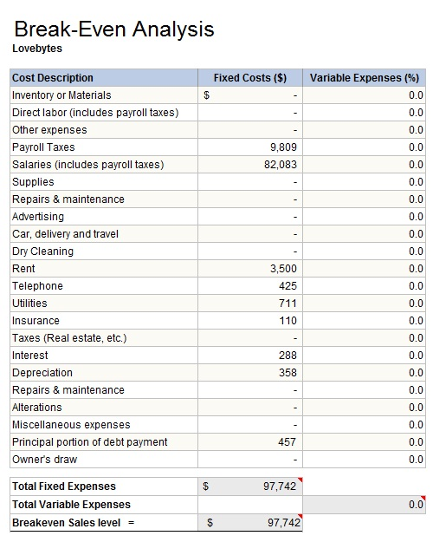

Our break-even analysis includes salary expense for all of employees, payroll taxes
,utilities, insurance, depreciation, principal and interest payment of our loan and rent. All costs are fixed as there is no cost of goods sold. As you can see, our company needs about $98,000 each month to break even. This means that we need to sell 247 packages at $395.40 packages each month in order to break even.
The salary expense is covered by the Virtual Enterprise Center in terms of our business contract and is included as a sale. This contract with the VEC is for 208 dating packages. If this contract is taken into account, we need to sell an additional 39 packages at trade fairs open houses, grand openings and on the Internet to break even. ( 82,083/$395.40 = 208) (208 + 39) * 395.40) = 97,66.38. In order to break even we will need to sell 247 package deals @ $. Below is a graphical representation of this data.

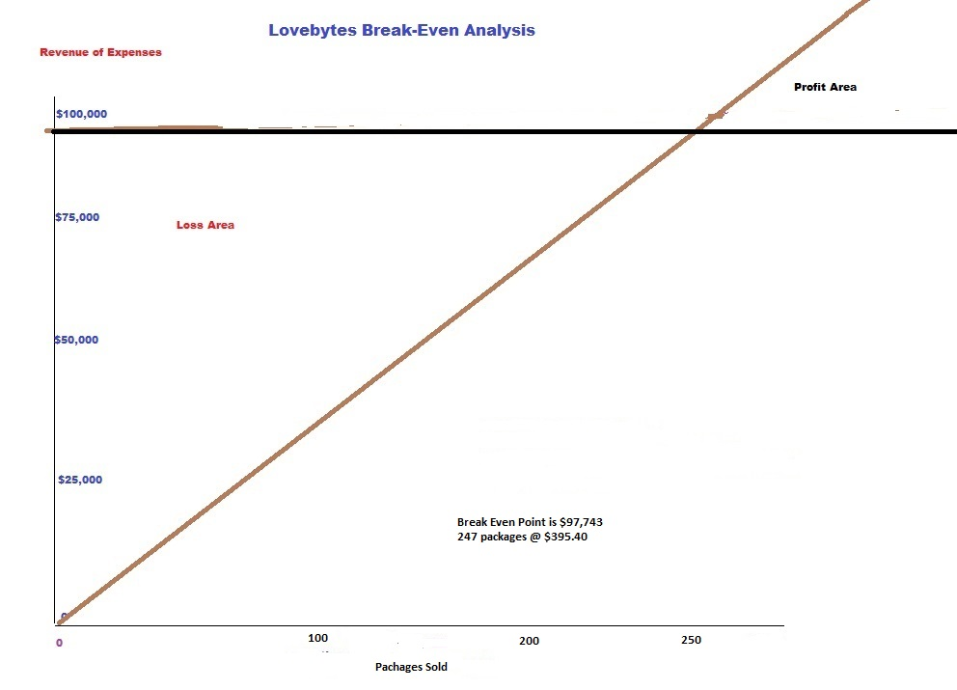

IV. Financial Data
Balance Sheet
Numbers were entered into this Excel spreadsheet. It is a computerized journal that will helped us keep things in balance. We used the Journal Transmittal page to post our transactions to the VB10 General Ledger Program.
The transactions are as follows: $41,000 was the seed money/initial investment.
$49,400 was the amount of our business loan.
$10,500 was used to buy equipment.
$2,400 was used to purchase furniture and fixtures.
Posting these number to the VB10 General Ledger will produce a beginning balance sheet need to be included in the Business plan proposal. See below for that document
Other transactions for November are as follows.
$82,083 was the business contract.
$15,420.60 was the income from our November open house and Internet sales.
$3,500 was our rent.
$1,136 was for utilities
$110 was our insurance expense
$745.70, $457.49 and $288.21: our loan payment including principal and interest paid.
$83,328 was our salary expense and deductions entry
$9,957.70 was the amount of our payroll taxes.
$29,426 was the total payment to the IRS for those payroll taxes
$8,158.14 was our payment to the Franchise Tax Board for State taxes.

Journal Entry Transmittal Sheet
Company Name | Lovebytes
Date | November
Account Name | Debit | Credit
Cash | $ 41,000.00
Capital Stock |  | $ 41,000.00
Initial Investment
Cash | $ 49,400.00
Note Payable |  | $ 49,400.00
Business Loan
Cash |  | $ -
Merchandise Inventory | $ -
purchased beg inventory
Cash |  | $ 10,500.00
Equipment | $ 10,500.00
purchased equipment
Cash |  | $ 2,400.00
Furniture & Fixtures | $ 2,400.00
purchase furniture

Lovebytes
Balance Sheet
October 31, 20XX

ASSETS

Cash $77,500.00
Accounts Receivable $0.00
Furniture & Fixtures $2,400.00
Supplies $0.00
Other Assets $0.00
Equipment $10,500.00
Prepaid Insurance $0.00
Accum Depreciation Furniture $0.00
Accum Depreciation Equipment $0.00
TOTAL ASSETS $90,400.00

LIABILITIES

Notes Payable $49,400.00
Accounts Payable $0.00
State Income Tax Payable $0.00
Federal Income Tax Payable $0.00
FICA Tax Payable $0.00
Medicare $0.00
Federal Unemployment Tax $0.00
State Unemployment Tax payable $0.00
Sales Tax Payable $0.00
State Disability Tax Payable $0.00
State Training Tax $0.00
TOTAL LIABILITIES $49,400.00

STOCKHOLDERS' EQUITY

Capital Stock $41,000.00
Retained Earnings $0.00
RETAINED EARNINGS $0.00
TOTAL STOCKHOLDERS' EQUITY $41,000.00
TOTAL LIABILITIES & STOCKHOLDERS' EQUITY $90,400.00

After completing the spreadsheet, the same data can be used month after month with just a few adjustments in sales, interest on the loan. The balance sheet for new companies should be for October, the month before the California simulation begins.
It should include any investment of capital from owners (Cash and common stock) and the business loan from the VEC. (Cash and Notes Payable) The use of money obtained from the business loan should be included. Cash would be reduced and other assets, such as inventory, operating capital , furniture and fixtures and equipment would be increased
Seed money (initial investment) was used to purchase equipment. Shares of stock valued at $10.00 per share were sold to the VEC in exchange for the money deposited into our bank account.
Seed money can be obtained by writing up a proposal for how the money will be used and sending it into the VEC. A more traditional approach is taken when borrowing money for equipment and inventory. It is the reason for the business loan. In the real world, not the virtual one, seed money would not exist.
Another form of revenue in virtual companies also exists. Signing bonuses. They are available at $6,000 per employee. Their purpose is to stimulate the virtual economy and allow employees to have money in November to buy products from the virtual market place. The total amount may be treated as a sale - a debit to cash and a credit to sales. The money must be paid to each employee by the banker and cannot be used for company purposes. To obtain signing bonus money, our accounting department wrote up an invoice for the total $6,000 times the number of students in the company plus 7.5% sales tax.
A written invoice was made up showing items purchased their cost and quantities, and sales tax. The invoice should be mailed to the VEC
The balance sheet for Lovebytes is included above. The following transactions are included
The tutorial takes a more real business-oriented approach in that the owners of the business invest in exchange for shares of stock, there are no signing bonuses and the loan money obtained is to purchase start-up assets..
Owners invested capital : $5,000 from CEO, CFO, Administrative Assistant, VP of Marketing/Sales, VP of IT, VP of Human Resources = $35,000
$1,000 invested by all other employees: $11,000
Total seed money invested = $41,000
This money is recorded as a capital investment in our S corporation by Lovebytes employees.
After coming up with our beginning balance sheet, we need to produce a projected income statement based on our expenses and commitments to the VEC. That statement appears below.

Projected income statement for November
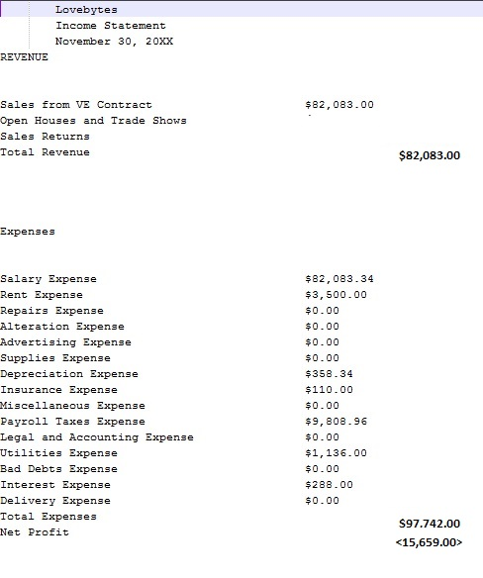
After producing a projected income statement, we saw that we would not even break even this month. We would lose money. We need to sell an additional 39 packages at $395.40
Projected income statements November thru April
Income Projections
$395.40 visitor checks are given out at the beginning of each open house and grand opening
It assumed that each one, 30 students, will purchase our package giving us $11,862.00 in cash sales at open houses in November, February
Our projected goal of sales at our grand opening will be $23,724.00 – 60 packages as we will have business partners, school personnel, politicians, an others attending.
Trade show projections are as follows:
Bakersfield Trade show in December = 100 sales @$395.40 = $39,540
Bay Area Trade Show in March = 100 sales @$395.40 = $39,540
San Diego Trade Show in April = 75 sales @$395.40 = $29,655
New York Trade Show in April = 50 sales @395.40 = $19,770
There might be some cash sales at the trade shows as well from non VE students.
Income Projections for Lovebytes April through November
LoveBytes
November-April
Income Projections
 | November
SALES
VE Contract for Salaries | $ 82,083.00
Open House/Trade Fair/Online | $ 15,420.00
Total Sales | $ 97,503.00
EXPENSES
Salary Expense | $ 82,083.34
Rent Expense | $ 3,500.00
Repairs Expense | $ -
Alterations Expense | $ -
Dry Cleaning Expense | $ -
Advertising Expense | $ -
Supplies Expense | $ -
Depreciation Expense | $ 358.34
Insurance Expense | $ 110.00
Miscellaneous Expense | $ -
Payroll Taxes Expense | $ 9,808.96
Legal And Accounting | $ -
Utilities Expense | $ 1,136.00
Bad Debts Expense | $ -
Interest Expense | $ 288.00
Delivery Expense | $ -
Total Expenses | $ 97,284.64
Net Income | $ 218.36

Income Projections for Lovebytes April through November
LoveBytes
November-April
Income Projections

 | December
SALES
VE Contract for Salaries | $ 82,083.00
Open House/Trade Fair/Online | $ 39,540.00
Total Sales | $ 121,623.00
EXPENSES
Salary Expense | $ 82,083.34
Rent Expense | $ 3,500.00
Repairs Expense | $ -
Alterations Expense | $ -
Dry Cleaning Expense | $ -
Advertising Expense | $ -
Supplies Expense | $ -
Depreciation Expense | $ 358.34
Insurance Expense | $ 110.00
Miscellaneous Expense | $ -
Payroll Taxes Expense | $ 9,808.96
Legal And Accounting | $ -
Utilities Expense | $ 1,136.00
Bad Debts Expense | $ -
Interest Expense | $ -
Delivery Expense | $ -
Total Expenses | $ 96,996.64
Net Income | $ 24,626.36

Income Projections for Lovebytes April through November
LoveBytes
November-April
Income Projections

 | January
SALES
VE Contract for Salaries | $ 82,083.00
Open House/Trade Fair/Online | $ 15,420.60
Total Sales | $ 97,503.60
EXPENSES
Salary Expense | $ 82,083.34
Rent Expense | $ 3,500.00
Repairs Expense | $ -
Alterations Expense | $ -
Dry Cleaning Expense | $ -
Advertising Expense | $ -
Supplies Expense | $ -
Depreciation Expense | $ 358.34
Insurance Expense | $ 110.00
Miscellaneous Expense | $ -
Payroll Taxes Expense | $ 9,808.96
Legal And Accounting | $ -
Utilities Expense | $ 1,136.00
Bad Debts Expense | $ -
Interest Expense | $ -
Delivery Expense | $ -
Total Expenses | $ 96,996.64
Net Income | $ 506.96

Income Projections for Lovebytes April through November
LoveBytes
November-April
Income Projections

 | February
SALES
VE Contract for Salaries | $ 82,083.00
Open House/Trade Fair/Online | $ 15,420.60
Total Sales | $ 97,503.60
EXPENSES
Salary Expense | $ 82,083.34
Rent Expense | $ 3,500.00
Repairs Expense | $ -
Alterations Expense | $ -
Dry Cleaning Expense | $ -
Advertising Expense | $ -
Supplies Expense | $ -
Depreciation Expense | $ 358.34
Insurance Expense | $ 110.00
Miscellaneous Expense | $ -
Payroll Taxes Expense | $ 9,808.96
Legal And Accounting | $ -
Utilities Expense | $ 1,136.00
Bad Debts Expense | $ -
Interest Expense | $ -
Delivery Expense | $ -
Total Expenses | $ 96,996.64
Net Income | $ 506.96

Income Projections for Lovebytes April through November
LoveBytes
November-April
Income Projections

 | March
SALES
VE Contract for Salaries | $ 82,083.00
Open House/Trade Fair/Online | $ 39,450.00
Total Sales | $ 121,533.00
EXPENSES
Salary Expense | $ 82,083.34
Rent Expense | $ -
Repairs Expense | $ -
Alterations Expense | $ -
Dry Cleaning Expense | $ -
Advertising Expense | $ -
Supplies Expense | $ -
Depreciation Expense | $ 358.34
Insurance Expense | $ 110.00
Miscellaneous Expense | $ -
Payroll Taxes Expense | $ 9,808.96
Legal And Accounting | $ -
Utilities Expense | $ 1,136.00
Bad Debts Expense | $ -
Interest Expense | $ -
Delivery Expense | $ -
Total Expenses | $ 93,496.64
Net Income | $ 28,036.36

Income Projections for Lovebytes April through November
LoveBytes
November-April
Income Projections

 | April
SALES
VE Contract for Salaries | $ 82,083.00
Open House/Trade Fair/Online | $ 49,425.00
Total Sales | $ 131,508.00
EXPENSES
Salary Expense | $ 82,083.34
Rent Expense | $ 3,500.00
Repairs Expense | $ -
Alterations Expense | $ -
Dry Cleaning Expense | $ -
Advertising Expense | $ -
Supplies Expense | $ -
Depreciation Expense | $ 358.34
Insurance Expense | $ 110.00
Miscellaneous Expense | $ -
Payroll Taxes Expense | $ 9,808.96
Legal And Accounting | $ -
Utilities Expense | $ 1,136.00
Bad Debts Expense | $ -
Interest Expense | $ -
Delivery Expense | $ -
Total Expenses | $ 96,996.64
Net Income | $ 34,511.36

Income Projections for Lovebytes April through November
LoveBytes
November-April
Income Projections

 | Nov-April
SALES
VE Contract for Salaries | $ 492,498.00
Open House/Trade Fair/Online | $ 174,676.20
Total Sales | $ 667,174.20
EXPENSES
Salary Expense | $ 492,500.04
Rent Expense | $ 17,500.00
Repairs Expense | $ -
Alterations Expense | $ -
Dry Cleaning Expense | $ -
Advertising Expense | $ -
Supplies Expense | $ -
Depreciation Expense | $ 2,150.04
Insurance Expense | $ 660.00
Miscellaneous Expense | $ -
Payroll Taxes Expense | $ 58,853.76
Legal And Accounting | $ -
Utilities Expense | $ 6,816.00
Bad Debts Expense | $ -
Interest Expense | $ 288.00
Delivery Expense | $ -
Total Expenses | $ 578,767.84
Net Income | $ 88,406.36

Cash Flow
Numbers to be entered into cash flow template.
- Documents to have at hand.
- Loan information
- Monthly printout of loan showing interest and principal paid each month
- Original investment by owners - Amount
- All expenses projected to be paid each month
- Projected amounts for trade shows and open houses
Cash Flow Numbers

Account | Amount
Amount Invested | $41,000.00
Loan Amount | $49,400.00
Cash Sales November | $15,420.00
Cash Sales January | $45,000.00
Cash from receivables January | $39,450.00
Cash from receivables April | $39,450.00
Salary Expense | $82,083.00
Rent Expense | $3,500.00
Insurance Expense | $110.00
Payroll taxes | $9,808.96
Utilities | $1,1136.00
Interest Expense November | $288.17
Interest Expense December | $285.50
Interest Expense January | $282.81
Interest Expense February | $280.12
Interest Expense March | $277.40
Interest Expense April | $274.67
Loan Payment | $745.58

Cash Flow Analysis Template
Lovebytes | 0
 | Start Up | November | December | January
Cash On Hand | $ 41,000.00 | $ 90,400.00 | $ 90,231.29 | $ 74,645.25
Cash Receipts
Cash Sales |  | $ 15,420.00 | $ - | $ 45,000.00
Cash From Receivables |  |  |  | $ 39,450.00
Salary Income VEC |  | $ 82,083.34 | $ 82,083.34 | $ 82,083.34
Loan | $ 49,400.00
Total Cash Receipts | $ 49,400.00 | $ 97,503.34 | $ 82,083.34 | $ 166,533.34
Total Cash Available | $ 90,400.00 | $ 187,903.34 | $ 172,314.63 | $ 241,178.59
Cash paid Out
Salary Expense |  | $ 82,083.34 | $ 82,083.34 | $ 82,083.34
Rent Expense |  | $ 3,500.00 | $ 3,500.00 | $ 3,500.00
Repairs Expense |  | $ - | $ - | $ -
Alterations Expense |  | $ - | $ - | $ -
Dry Cleaning Expense |  | $ - | $ - | $ -
Advertising Expense |  | $ - | $ - | $ -
Supplies Expense |  | $ - | $ - | $ -
Insurance Expense |  | $ 110.00 | $ 110.00 | $ 110.00
Misc. Expense |  | $ - | $ - | $ -
Payroll Taxes |  | $ 9,808.96 | $ 9,808.96 | $ 9,808.96
Legal And Accounting |  | $ - | $ - | $ -
Utilities Expense |  | $ 1,136.00 | $ 1,136.00 | $ 1,136.00
Bad Debts Expense |  | $ - | $ - | $ -
Interest Expense |  | $ 288.17 | $ 285.50 | $ 282.81
 | $ -
Loan Payment |  | $ 745.58 | $ 745.58 | $ 745.58
Capital Purchases | $ - |  |  | $ -
Total Expenditures | $ - | $ 97,672.05 | $ 97,669.38 | $ 97,666.69
Total Cash Out | $ - | $ 97,672.05 | $ 97,669.38 | $ 97,666.69
Cash Balance | $ 90,400.00 | $ 90,231.29 | $ 74,645.25 | $ 143,511.90

February | March | April
$ 143,511.90 | $ 143,351.24 | $ 127,773.30
$ 15,420.00 | $ - | $ -
 | $ - | $ 39,450.00
$ 82,083.34 | $ 82,083.34 | $ 82,083.34
$ 97,503.34 | $ 82,083.34 | $ 121,533.34
$ 241,015.24 | $ 225,434.58 | $ 249,306.64
$ 82,083.34 | $ 82,083.34 | $ 82,083.34
$ 3,500.00 | $ 3,500.00 | $ 3,500.00
$ - | $ - | $ -
$ - | $ - | $ -
$ - | $ - | $ -
$ - | $ - | $ -
$ - | $ - | $ -
$ 110.00 | $ 110.00 | $ 110.00
$ - | $ - | $ -
$ 9,808.96 | $ 9,808.96 | $ 9,808.96
$ - | $ - | $ -
$ 1,136.00 | $ 1,136.00 | $ 1,136.00
$ - | $ - | $ -
$ 280.12 | $ 277.40 | $ 274.67
 |  | $ -
$ 745.58 | $ 745.58 | $ 745.58
$ 97,664.00 | $ 97,661.28 | $ 97,658.55
$ 97,664.00 | $ 97,661.28 | $ 97,658.55
$ 143,351.24 | $ 127,773.30 | $ 151,648.09
Financial Write-Up
Balance Sheet
The beginning balance sheet contains the amount of money invested by our employees in the amount of $41,000. It also shows the amount received from the business loan $49,400, After the loan was obtained, start up assets were purchased: server, computers, desks office chairs filing cabinets, etc.
Income Statements - Projected
The projected income statement included cash sales from open houses, the VE business contract amount, projected expenses from the Standard Rates and Payments for Companies form.
A straight-line depreciation method was used for three years on the equipment and fixtures and furniture. The interest was calculated on the loan from an amortization table, the payroll was determined by the business contract template for payroll. From that we obtained all the deductions and the amounts necessary to calculate payroll taxes.
We entered these amounts n the VB10 General Ledger Program to create a projected income statement for November. A spreadsheet template was used to calculate and project revenue and expenses from November through April.
Cash Flow Statement
A Cash-Flow Excel template was used to create the report. Start up cash from the owners investment was entered, the loan from the VEC to obtain beginning November cash balance. Open house sale projections were entered for the months that we will not attend a trade show. as well as the amount for the business contract. All expenses were entered for each month. The only one that changed was the interest expense on the loan. Trade show cash from receivables was entered the month after the trade show for each of the three trade shows: Bakersfield, Bay Area and San Diego. And New York
Business loan is for seven years at 7% interest. Total amount of loan is $49,400
Appendix
Month and Year
Business Loan Application
Virtual Enterprise loans are for a term of 84 months at 7% interest for new loan and 6% interest for loan consolidation.

Name of Firm: | Lovebytes Computer Dating Service
Address of Firm: | 14100 Ridge Road
City and State: | Ventana , California
Zip: | 93888
Business Plan Submission Date (or projected date): | October 20, 20xx
Date of business plan presentation (or projected date): | November 1, 20xx
Number of Employees: | 17
Number of years in business: | First Year
Do you have other loans with the VEC? | Yes _______ Amount: ______________________  No ___X____
Purpose of loan - Check all that apply: | ___X__ Start-Up Expenses – examples: office equipment, basic supplies, etc.  _____ Inventory Purchases for up to 3 months  ___X__ Basic Office Expenses for 3 – 5 months – examples: rent, utilities, business insurances, workman’s comp insurance, car insurance, Internet & cable, etc.  _____ New Construction, Expansion, and/or Repair  _____ Other (Explanation needed)
Complete all that apply below:
Start-Up Expenses*:  (enter total dollar amount rounded off ) | $13,400
Inventory Purchase with basic list* (up to 3 months):
(enter total dollar amount rounded off )
Basic Office Expenses* (3-5 months): (enter total dollar amount rounded off) | $36,000 $12,000 for 3 months
New Construction, Expansion, and/or Repair with explanation*:
(enter total dollar amount rounded off))
Other with explanation*: (enter total dollar amount rounded off)
Projected Monthly Expenses ($): | $97,672.05
Projected Monthly Income ($): | Average = $105,749.66
Your Name: | Janet Belch
Title: | CFO
Date: | October 20, 20xx
Loan Amount Requested: | $49,400

*A list of the following needs to be completed and turned in on the Loan Application Information form with this application before approval of loan:
- All Start-Up Expenses – such as, computers, desks, phones, etc. Anything needed open the company. Total for all items.
- Inventory Purchase Expenses – Basic list of items to be sold for up to 3 months only. These items will be ordered from Wholesale Marketplace once established.
- Basic Monthly Office Expenses – such as, rent, utilities, insurances, Internet, etc. These expenses are to be listed individually with a dollar amount per month. The loan may provide up to 5 months of basic office expenses. Monthly amounts for each item needed. Total for month and number of months to be covered needed. Salary & payroll taxes are NOT a part of this expense as they will deposited into company account via contract.
- New Construction, Expansion, and/or Repair Expenses with explanation - List of what is to be done. Total for all work.
- Other Expenses not in above list with explanation of what expenses will be used for. Total for these expenses.

Start-Up Budget
We need to buy the equipment and get it in place with the software and form-mailer questionnaire
installed on all machines. We need to be ready November 1 to begin operations
We have the business loan money, $49,400 for the equipment and money for minimal operating expenses. Detail of equipment and furniture and fixtures is in a table above.
We need to set up our accounting system with the chart of accounts and the beginning balances,
Before turning in the business plan, check for consistency of numbers: projected income statements and cash flow, balance sheet and loan information, payroll information and business contract. The numbers in the plan are used in multiple places and should be the same.
Loan Amortization table

Calculation Results
Loan Amount: $49,400.00 ~ Term of the Loan: 7 years ~ Interest Rate: 7.000%
Monthly mortgage payments: $745.58 ~ Total interest paid over the life of the loan: $13,228.58
If your current rate on a 7-year fixed loan is 7.000%, would you like to see if you can get it lower?
Amortization Table
Year | Loan Balance | Yearly Interest Paid | Yearly Principal Paid | Total Interest
2013 | 48,482.51 | 573.67 | 917.49 | 573.67
2014 | 42,747.67 | 3,212.10 | 5,734.84 | 3,785.77
2015 | 36,598.26 | 2,797.53 | 6,149.41 | 6,583.30
2016 | 30,004.30 | 2,352.99 | 6,593.95 | 8,936.28
2017 | 22,933.67 | 1,876.31 | 7,070.63 | 10,812.59
2018 | 15,351.91 | 1,365.17 | 7,581.77 | 12,177.77
2019 | 7,222.05 | 817.09 | 8,129.85 | 12,994.86
2020 | 0.00 | 233.73 | 7,222.05 | 13,228.58
Year | Loan Balance | Yearly Interest Paid | Yearly Principal Paid | Total Interest

There are different criteria for the financial section of the business plan if you are an existing business that is continuing. Check the rubrics for the business plan for this information</p>

